# Appendix B: Installation Guide

Below are the steps necessary to be able to interact with the front-end interface we developed. These directions cover all steps needed, from installation to interacting with the tool.

## Neo4j and NeoDash

**STEP 1-**

Fill in the details and continue to download.

**On the next page, make sure you follow the instructions on the page. Make sure to copy the activation key.**

**Step 2-**

Start installing Neo4j downlaoded file.

After completing the installation, Run Neo4j.

**Step 3-**

After running Neo4j, Paste the activation key which was copied from the web.

**Step 4- Creating Project or uploading an existing Project**

The project file can be downloaded from the GitHub repository. **To access GitHub repository**( [29] )

Download the GitHub repository and select the database folder. Then you can access the DAEN_690_Project folder.

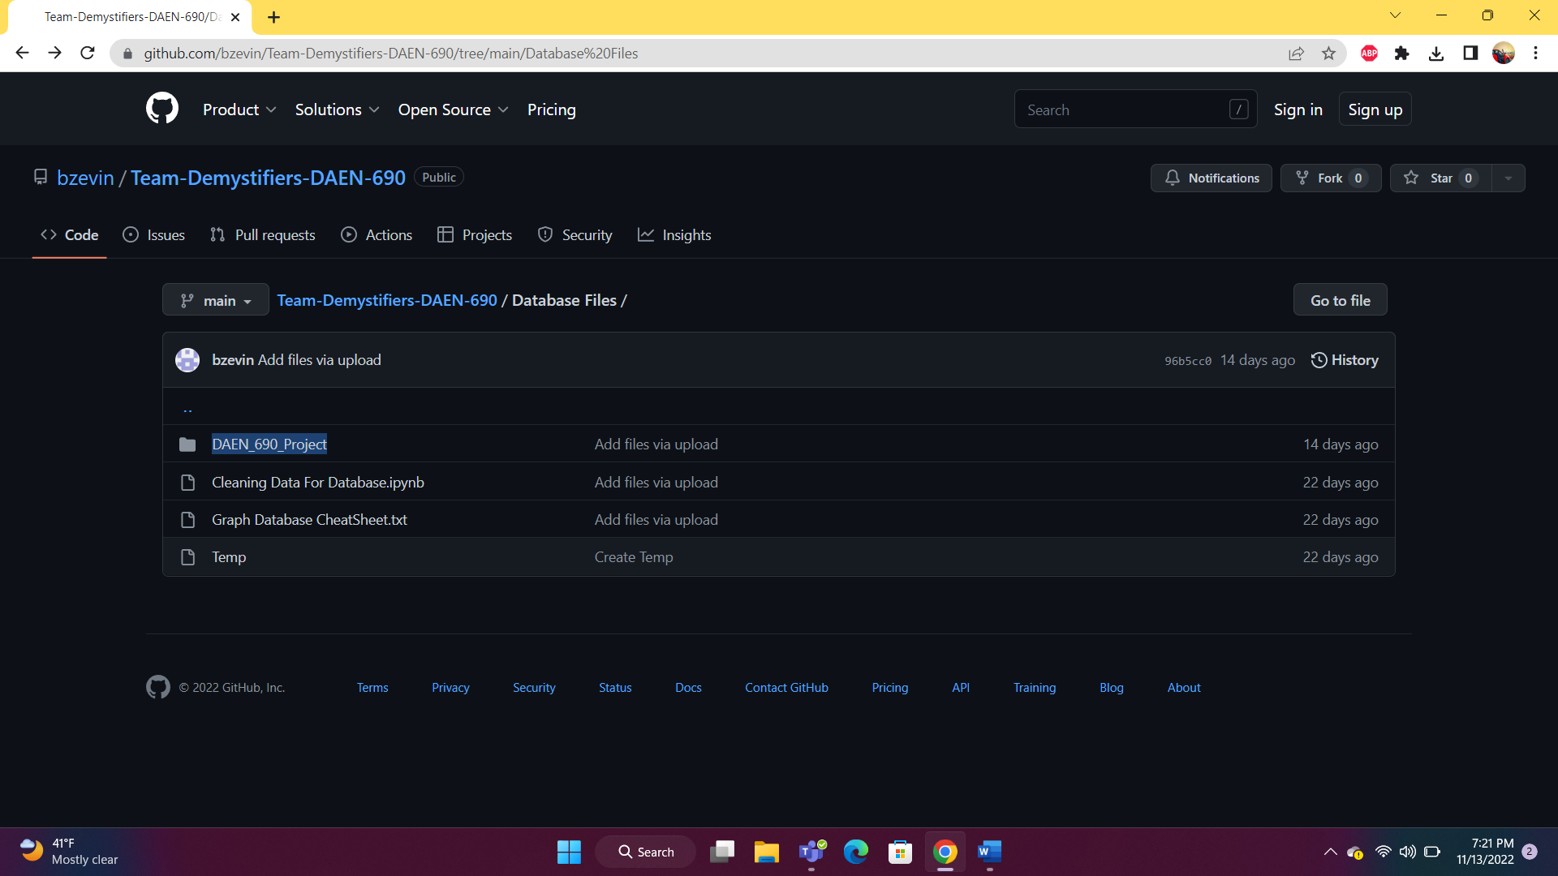

After downloading the GitHub repository, to create or upload an existing project click on new and select Create project and select Create project from directory.

Select the project folder which is downloaded from GitHub and then select the folder into Neo4j.

**Step 5-**

After importing the project, create new DBMS from dumb.

To create DBMS, Give a name and a password then select create. Make sure to change the version to 4.4.11.

**Step 6- Installing NeoDash**

Open <https://install.graphapp.io/> on the web browser and select NeoDash.

**Step 7- Start Database and connect to Neodash**

After installing Neodash, Start the database.

Select Graph apps and open NeoDash.

**Step 8- Connect Neodash to Neo4j**

Make sure that the database is in active Status and then open Neodash.

After Connecting the Neo4j Desktop, you should be able to use the dashboard.

**Step 9 – Accessing Dashboard**

After connecting NeoDash to Neo4j, to access the dashboards upload them into NeoDash. Select upload on the left side of the NeoDash menu.

And then select to upload from file.

Select the Dashboard from the folder which was downloaded from GitHub. You can find the Dashboard files in the DAEN_Project folder. [29]

You can follow the following path to access the Dashboard

[Team-Demystifiers-DAEN-690/Database Files/DAEN_690_Project/]

After selecting the dashboard Select Load Dashboard on the Top right side of the Pop-up.

And you should be able to access the dashboard.

